**How would you describe Anglican identity or Anglican theology?**

Anglicans are a diverse monolithic mosaic of 80+ million people. Of course they have an identity! Sometimes it is easier to say what people aren’t instead of what they are. As a person who has recently “become” Anglican I can assure my new community that everyone knows that Anglicans are not evangelicals. I am also sure that Anglicans are not Catholics.

I agree that it is difficult to present a singular idea of Anglican theology. However, I am positive that Anglican theology rests somewhere between the theology of the “squalid sluttery of a fanatical conventicle” (terms one Anglican used to describe evangelicals) and Catholics. I would be remiss if I did not point out that Anglican identity possesses a feeling of being old perhaps ancient. Anglican often embrace that there faith is more there than can be encompassed by their own life spans. I disagree with Jeff Fisher’s position that Anglicans do not have doctrine of our own.

I enjoyed the description of Anglican being Catholic Evangelicals as perhaps the easiest framework to flesh out but was left wondering; Do Anglican struggle with their identity because of the way they were founded or are they strong in their identity and spend time reflecting on it.

**What would you add or subtract to the discussion of Anglican theology in the lecture or the reading from Dr. Witt?**

To describe this amazing community without the use of Art is challenging. I would suggest the inclusion of some Art that conveys what the lecture and reading presented. For example the compass rose or:

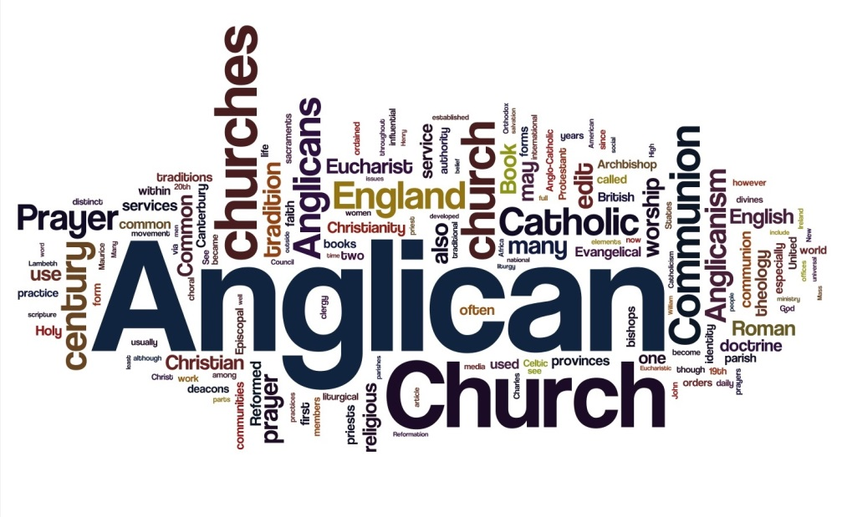

**What stood out about the readings or lecture?**

“Hence “Catholicism” and “Evangelicalism” are not two separate things which the Church of England must hold together by a great feat of compromise. . . . A church’s witness to the one Church of the ages is a part of its witness to the Gospel of God.” Ramsey, Archbishop of Canterbury

**Craig Rogalsky**

**01/28/2016 6:30 pm**

**How would you describe Anglican identity or Anglican theology?**

Anglicans are a diverse monolithic mosaic of 80+ million people. Of course they have an identity! Sometimes it is easier to say what people aren’t instead of what they are. As a person who has recently “become” Anglican I can assure my new community that everyone knows that Anglicans are not evangelicals. I am also sure that Anglicans are not Catholics. I enjoyed the description of Anglicans as being Catholic Evangelicals as perhaps the easiest framework to flesh out.

I agree that it is difficult to present a singular idea of Anglican theology. However, I am positive that Anglican theology rests somewhere between the theology of the “squalid sluttery of a fanatical conventicle”  (terms one Anglican used to describe evangelicals) and Catholics. I would be remiss if I did not point out that Anglican identity possesses a feeling of being old perhaps ancient. Anglicans often embrace that their faith is more than can be encompassed by their own life spans. I disagree with Jeff Fisher’s position that Anglicans do not have doctrine of our own.

I am left curious as to; Do Anglicans struggle with their identity because of the way they were founded or are they strong in their identity and spend time reflecting on it.

**What would you add or subtract to the discussion of Anglican theology in the lecture or the reading from Dr. Witt?**

To describe this amazing community without the use of Art is challenging. I would suggest the inclusion of some Art that conveys what the lecture and reading present. For example the compass rose or:



Title: Anglican Theggology

**What stood out about the readings or lecture?**

“Hence “Catholicism” and “Evangelicalism” are not two separate things which the Church of England must hold together by a great feat of compromise. . . . A church’s witness to the one Church of the ages is a part of its witness to the Gospel of God.”  Ramsey, Archbishop of Canterbury